Predictive Model for Sales Prices of Homes (Ames, Iowa)

Using Multiple Linear Regression

August 15, 2018

Andy Ho | An Nguyen | Matthew Norton

Table of Contents

Introduction 3

Data – Descriptive Statistics 3

Analysis 1 3

Introduction 3

Restatement of Problem 3

Exploratory Statistics on Train.csv 3

Selection Process 4

Summary Table of Model Assumptions 4

Assumptions 4

Residual Plots 5

5

Model 5

Fitted Model 5

Three Regression Equations 5

Parameters/Estimates 6

Interpretation 6

Confidence Intervals 6

Conclusion 6

Analysis 2 7

Restatement of Problem 7

Model Selection 7

Checking Assumptions 7

Residual Plots 8

Influential Point Analysis 10

Comparing Competing Models 10

Conclusion 11

# **Introduction**

Ask a home buyer to describe their dream house, and they probably won't begin with the height of the basement ceiling or the proximity to an east-west railroad. But this Kaggle competition's dataset proves that much more influences price negotiations than the number of bedrooms or the presence of a white-picket fence. With 79 explanatory variables describing (almost) every aspect of residential homes in Ames, Iowa, this competition challenges you to predict the final price of each home

## Data – Descriptive Statistics

The [Ames Housing dataset](http://www.amstat.org/publications/jse/v19n3/decock.pdf) was compiled by Dean De Cock for use in data science education. It's an incredible alternative for data scientists looking for a modernized and expanded version of the often-cited Boston Housing dataset.

* File Name: test.csv (461 KB) and train.csv (461 KB)
* File Origin: <https://www.kaggle.com/c/house-prices-advanced-regression-techniques/data>
* Data Dimensions

|  |  |  |
| --- | --- | --- |
|  | **Observations** | **Variables** |
| **Train** | 1460 | 81 |
| **Test** | 1459 | 80 |

* Data Clean Method
  + After adding an additional SalePrice column (with blank values) to test.csv, we merged train.csv and test.csv to create a masterAn.csv file with 2919 observations and 81 variables.
  + Using excel, performed a global find ‘NA’ and replaced with ‘0’
  + Since Neighborhood=NAmes, after the global edit, we manually changed ‘0mes’ back to “NAmes.”

# **Analysis 1**

## Introduction

Century 21 Ames only sells home in NAmes, Edwards, and BrkSide neighborhoods and would like to get an estimate of how the SalePrice of each house is related to the square footage of the living area of the house (GrLivArea) and if the SalesPrice (and its relationship to square footage) depends on which neighborhood the house is located. This portion of the report will build a model with the provided dataset and provide our conclusion that quantifies the relationship between living area and sale price with respect to the three neighborhoods.

## Restatement of Problem

Century 21 Ames would like to simply get an estimate of how the SalePrice of the house is related to the square footage of the living area of the house (GrLIvArea) and if the SalesPrice (and its relationship to square footage) depends on which neighborhood the house is located in. Using the 383 observations for the three neighborhoods, find the model that best fits the relationship between living area and sale price.

## Exploratory Statistics on Train.csv

* Descriptive Statistics: There are 1460 observations. Below are the means and standard deviations for SalePrice and GrLivArea

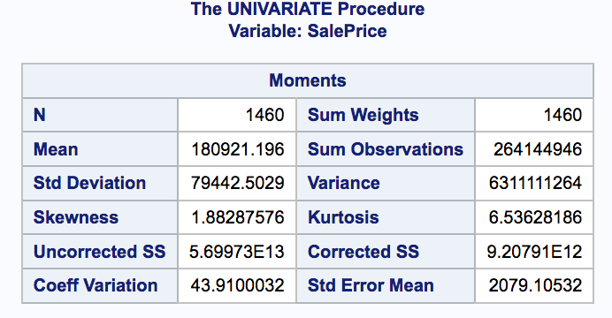

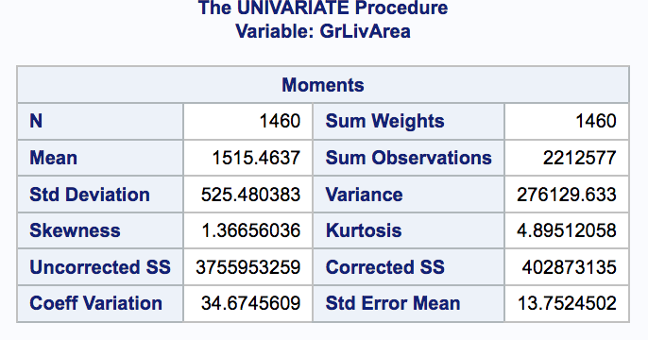

* Distribution of SalePrice: Evidence against normal distribution of Sale price in the three neighborhoods. Judging by the histogram, evidence of right skewness.
* Averages by neighborhoods and all three combined

|  |  |  |  |
| --- | --- | --- | --- |
| **Neighborhood** | **Number of Properties** | **Avg. Living Area** | **Avg. Sale Price** |
| NAmes | 225 | 1310.31 | $145,847.08 |
| Edwards | 100 | 1340.04 | $128,219.70 |
| BrkSide | 58 | 1203.07 | $124,834.05 |
| All Three | 383 | 1301.83 | $138,062.50 |

## Selection Process

This section will demonstrate the various models ran, results of each, and our decision on which model is best based on how it satisfies the following assumptions:

1. Normality 2. Linearity 3. Equal Variance 4. Independence 5. Outliers

## Summary Table of Model Assumptions

|  |  |  |  |  |  |  |
| --- | --- | --- | --- | --- | --- | --- |
| **Vanilla Regression** | | | | | | |
| **Model** | **Normality** | **Linearity** | **Equal Variance** | **Independence** | **Outliers** | **R^2** |
| Original Data | ✔ |  |  | ✔ |  | 0.447 |
| Log-Linear | ✔ |  | ✔ | ✔ |  | 0.465 |
| Linear-Log | ✔ |  |  | ✔ |  | 0.466 |
| Log-Log | ✔ | ✔ | ✔ | ✔ |  | 0.512 |
| Original Data (Outliers Addressed) | ✔ | ✔ | ✔ | ✔ | ✔ | 0.523 |
| Log-Linear (Outliers Addressed) | ✔ | ✔ | ✔ | ✔ | ✔ | 0.525 |
| Linear-Log (Outliers Addressed) | ✔ |  | ✔ | ✔ | ✔ | 0.0498 |
| Log-Log (Outliers Addressed) | ✔ |  | ✔ | ✔ | ✔ | 0.053 |

## Assumptions

After running 8 different models, there is sufficient evidence that the vanilla regression model using the original data (three neighborhoods) while addressing the outliers is the best fit model. The following addresses the assumptions. **Refer to Appendix 5 for more charts and values**.

1. **Normality:** Judging by the histogram of the residuals, the original data (outliers addressed) there is no evidence that the residuals do not follow a normal distribution and looks slightly better than the rest.
2. **Linearity:** Judging by the scatterplots, the original data (outliers addressed) looks slightly better than the other three outliers addressed (log-linear, linear-log, log-log). The plots are randomly scattered. There is sufficient evidence for linearity.
3. **Equal Variance:** Judging by the residual scatterplots and QQplot, the original data (outliers addressed) looks better than the rest and shows sufficient evidence for equal variance.
4. **Independence:** We will assume independence, although the data gathering process was not explained.
5. **Outliers:** There are a few outliers that were addressed. Specifically, homes in the Edwards neighborhood with living area greater than 4,000 sq. ft. and two homes (one in Edwards and NAmes) with sale price over $300,000.

## Residual Plots

## 

Residual Plots Cook’s D (middle right)

## Model

The model assigns SalePrice as the response variable and GrLivArea as the explanatory variable. Based on the scatterplots, there is strong evidence the model will have different slopes and intercepts for each significant parameter.

*PredictedSalesPrice = ß0 + ß1 * (BrkSide) + ß2 * (Edwards) + ß3 * (GrLivAreaper100) + ß4 * (BrkSide * GrLivAreaper100) + ß5 * (Edwards * GrLivAreaper100)*

## Fitted Model

PredictedSalesPrice = $80,325 – $60,354 * (BrkSide) – $43,225 * (Edwards) + $4,956 * (GrLivAreaper100) + $3,760 * (BrkSide * GrLivAreaper100) + $2,059 * (Edwards * GrLivAreaper100)

## Three Regression Equations

NAmes Neighborhood: *PredictedSalesPrice= $80,325 + $4,956 * GrLivAreaper100*

BrkSide Neighborhood: *PredictedSalesPrice= $19,971 + $8,716 * GrLivAreaper100*

Edwards Neighborhood: *PredictedSalesPrice= $37,100 + $7,015 * GrLivAreaper100*

## Parameters/Estimates

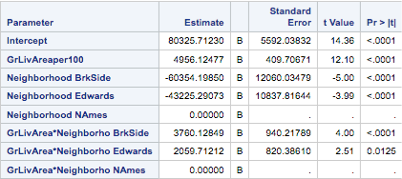

### Interpretation

* + The estimated average sale price for houses in the NAmes neighborhood with zero square feet of living area is $80,327.
  + In the NAmes neighborhood for every 100 square feet increase in living area the estimated average sale price will increase by $4,956.
  + The estimated average sale price for houses in the BrkSide neighborhood with zero square feet of living area is $19,971.
  + In the BrkSide neighborhood for every 100 square feet increase in living area the estimated average sale price will increase by 8,716.
  + The estimated average sale price for houses in the Edwards neighborhood with zero square feet of living area is $37,100.
  + In the Edwards neighborhood for every 100 square feet increase in living area the estimated average sale price will increase by $7,015.

### Confidence Intervals

95% CI of NAmes’ intercept: ($69330.31, $91321.11)

95% CI of difference between NAmes and Brkside’s intercept: ($-84067.36, $-36641.03)

95% CI of difference between NAmes and Edwards’ intercept: ($-64535.25, $-21915.32)

## Conclusion

After using the vanilla regression and addressing the outliers of a living area greater than 4,000 sq. ft. and a sales price of over $300,000, there is significant evidence that both the neighborhood and square footage of the living area influence the estimated sale price of the home in Ames. The intercept in this model provides an estimated average sale price of $80,327 for a house with a living area of zero square feet in the NAmes neighborhood, with a 95% CI of ($69330.31, $91321.11). For a house with a living area of zero square feet, the model gives us an estimated average sales price decrease of $60,354 with a 95% CI of ($36641.03, $84067.36) from houses in the NAmes neighborhood for the BrkSide neighborhood and an estimated average sales price decrease of $43,225 with a 95% CI of ($21915.32, $64535.25) from the NAmes neighborhood for the Edwards neighborhood. For every increased living area of one hundred square feet the estimated average sales price increases $4,956 for a home in the NAmes neighborhood, the estimated average sales price in the BrkSide neighborhood increases $3,780 more than the houses in the NAmes neighborhood and the estimated average sale price in the Edwards neighborhood increases $2,059 more than the NAmes neighborhood. Since this is an observational study, only associations can be made to those three neighborhoods.

# **Analysis 2**

## Restatement of Problem

Using all the provided variables Century 21 Ames would like to predict the sale price of any of the homes in their inventory. Using different fitting algorithm find the best fit model that can describe sale price of a home vs some or all the provided explanatory variables.

## Model Selection

Forward selections, backward eliminations, and stepwise selection were applied to the all the variables provided by Century 21 Ames to find the best house sale price predictive model. A fourth method (CUSTOM) was used where we selected all variables that resulted in a correlation when plotted against sale price. For categorical variables if a category showed an increase or decrease in sale price when compared to its counterparts this variable was included into the model. **Refer to Appendix 0 – SAS Code for Project** under “Analysis 2” for SAS code for each variable model selection.

## Checking Assumptions

Although all the assumptions were not entirely satisfied, we assumed central limit theorem would take effect with a sizable dataset. Our approach during the model selection influenced our conclusions on the following assumptions:

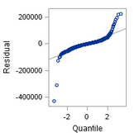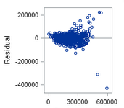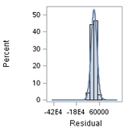

**Histogram of Residuals Scatterplot of Residuals QQ Plot of Residuals**

1. Normality: There is no strong evidence against normality when considering the histogram of residual plots. With regards to all the explanatory variables, it is not ideal to have normality for every predictor considered in each model.
2. Linearity: There is no strong evidence against linearity when considering the scatterplots of residuals. Referring to Appendix 9, there is a series of pairwise plots of the explanatory variables to the response variable of SalesPrice. Again, although not ideal to have linearity for every selected predictor, we proceeded with accepting our selected variables based of a reasonable adj. R^2 and low Kaggle score.
3. Equal Variance: There is no strong evidence against equal variance when considering the QQPlot of residuals. On the top-end of the tail, there is evidence of some points not having equal variance but due to the size of the data set, we allowed for the observations to stay in model. After proceeding with the various models, it was concluded that the observations were not influential enough to be removed as it did not greatly affect the prediction score.
4. Independence: We will assume independence, although the data gathering process was not explained.
5. Outliers: There is evidence of a few outliers but we determined it was not influential enough to remove as it did not significantly improve the Kaggle score for each model.

### Residual Plots

 

 

 

### Influential Point Analysis

The following uses the CUSTOM model (**refer to Appendix 1 : SAS and R Code for Project under Analysis 2**). Judging by the Cook’s D (middle right) chart, there are a value that potentially is influential ( > 2.0) and evidence that leverage was acceptable. Further investigation uncovered ID 524 and 1299 to be potentially influential. After removing observation ID 524 and 1299, we re-run and re-submitted predictions to Kaggle. Unexpectedly, the score increased by .15. Therefore, we concluded to leave the influential points in our dataset.



## Comparing Competing Models

(refer to Appendix 14 for proof of Kaggle submission)

|  |  |  |  |
| --- | --- | --- | --- |
| **Predictive Models** | **Adjusted R2** | **CV PRESS** | **Kaggle Score** |
| Forward | 0.8654 | 1.284085E12 | 0.15937 |
| Backward | 0.9198 | 1.2082E12 | 0.17309 |
| Stepwise | 0.8654 | 1.284085E12 | 0.17623 |
| CUSTOM | 0.8497 | AIC-31699  AICC – 31704  SBC - 30548 | 0.18171 |

## Conclusion

Forward selection model produced the best Kaggle score of 0.15937. The following are significant predictors (both positive and negative influence) on the predicted sales price:

* MSSubClass
* Neighborhood BrDale
* Neighborhood BrkSide
* Neighborhood ClearCr
* Neighborhood CollgCR
* Neighborhood Edwards
* Neighborhood Gilbert
* Neighborhood IDOTRR
* Neighborhood MeadowV
* Neighborhood Mitchel
* Neighborhood NAmes
* Neighborhood NWAmes
* Neighborhood NoRidge
* Neighborhood NridgHt
* Neighborhood OldTown
* Neighborhood SWISU
* Neighborhood Sawyer
* Neighborhood SawyerW
* Neighborhood StoneBr
* Neighborhood Timber
* OverallQual
* ExterQual Ex
* ExterQual Gd
* BsmtExposure Av
* BsmtExposure Gd
* BsmtExposure Mn
* BsmtFinSF1
* GrLivArea

In running the various models, we noticed that each run of the same model could produce different output and produce Kaggle scores between 0.15937 to 0.24. We discovered SAS’s auto-selection of variables could be different so we “seed” in SAS to freeze the test run that produced the best Kaggle score. It is also worth exploring that a higher adjusted R^2 does not mean the Kaggle score will be better than another with a lower adjusted R^2. During the cross-validation, about 146 observations were left out of the Forward Selection model. Another point of interest is when creating predictive model, through SAS’s auto-selection (for Forward, Backwards, Stepwise) the assumptions of linearity, equal variance, and normality do not necessarily hold. Therefore, we conclude that assumptions as well as multiple linear regression are not always ideal in predictive models – we suspect algorithms like Random Forest or Logistics Regression could be a better fit.